Software Requirements Specification

for

Hotel Management System, Release 1.0

**Version 1.0 approved**

**Prepared by Group 2**

**September 30, 2021**

**Table of Contents**

**1.** **Introduction** **1**

1.1 Purpose **1**

1.2 Document Conventions 1

1.3 Project Scope and Product Features 1

1.4 References **1**

**2.** **Overall Description** **1**

2.1 Product Perspective 1

2.2 User Classes and Characteristics 2

2.3 Operating Environment 2

2.4 Design and Implementation Constraints 3

2.5 Assumptions and Dependencies **3**

**3.** **System Features** **3**

3.1 Check in 3

3.1.1 Description 3

3.1.2 Functional Requirements 3

3.2 Create, View, Update, Delete Room Information 4

3.2.1 Description 4

3.2.2 Functional Requirements 4

3.3 Create, View, Update, Delete Services Information 5

3.3.1 Description 5

3.3.2 Functional Requirements 5

3.4 Create, View, Update, Delete Customer Information 6

3.4.1 Description 6

3.4.2 Functional Requirements **6**

**4.** **Data Requirements** **7**

4.1 Logical Data Model 7

4.2 Data Dictionary 7

4.3 Reports 8

4.3.1 Check-in history Report 9

4.3.2 Check-out history Report 9

4.4 Data Integrity, Retention, and Disposal 11

5. **External Interface Requirements** **11**

5.1 User Interfaces 11

5.2 Software Interfaces 11

5.3 Hardware Interfaces 12

5.4 Communications Interfaces 12

**6.** **Quality Attributes** 12

6.1 Usability Requirements 12

6.2 Performance Requirements 12

6.3 Security Requirements 13

6.4 Safety Requirements 13

6.5 Availability Requirements 13

6.6 Robustness Requirements 13

**Revision History**

|  |  |  |  |
| --- | --- | --- | --- |
| **Name** | **Date** | **Reason For Changes** | **Version** |
| Group 2 | 30/9/2021 | initial draft | 1.0 draft 1 |
|  |  |  |  |

# Introduction

## Purpose

This SRS describes the functional and nonfunctional requirements for software release 1.0 of the Hotel Management System (HMS). This document is intended to be used by the members of the project team who will implement and verify the correct functioning of the system. Unless otherwise noted, all requirements specified here are committed for release 1.0.

## Document Conventions

No special typographical conventions are used in this SRS.

## Project Scope and Product Features

The HMS will permit Hotel Staff to manage hotels off-line more easily and efficiently. A detailed description is available in the *Hotel Management System Vision and Scope Document* [1], along with the features that are scheduled for full or partial implementation in this release.

## References

1. *Group 2, Hotel Management System Vision and Scope Document,*  
   https://docs.google.com/document/d/12JWo4THLJEoi1ONdw-jxfQ6DY-OVCJB7/edit?usp=sharing&ouid=116791822988339723734&rtpof=true&sd=true

# Overall Description

## Product Perspective

The Hotel Management System is a new software system that replaces the current manual processes for hotel check-in, check-out and management in the <<Hotel Name >> hotel. The context diagram in Figure 1 illustrates the external entities and system interfaces for release 1.0. The system is expected to evolve over several releases.

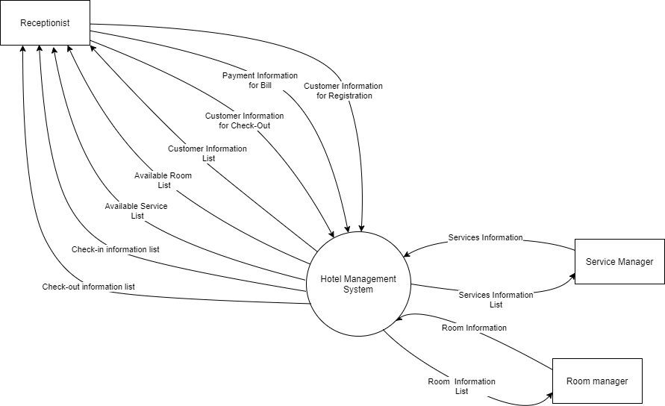

**Figure 1. Context diagram for release 1.0 of the Hotel Management System.**

## User Classes and Characteristics

|  |  |
| --- | --- |
| Receptionist | A Receptionist is a <<Hotel Name>> employee who works as a receptionist to handle the customer check-in and check-out of the hotel and manage basic information of customer for that. There are about 12 Receptionists they will provide room information and services for customers to select and use. Most of the Receptionist will need training in the use of the hardware and software for the HMS |
| Room Manager | The Room Manager is a hotel employee who establishes and maintains rooms available in the hotel. Some rooms may not be available because they are already taken. The Room Manager will need to edit existing rooms for any hotel room changes. |
| Service Manager | The Service Manager is a hotel employee who establishes and maintains services available from the hotel. Some services may not be available for some reason.The Service Manager will need to edit existing services periodically. |
|  |  |

## Operating Environment

OE-1: The HMS shall operate correctly with the following OS: Windows version 7, 8 and 10, Linux, macOS versions 10.12 and above.

OE-2: The HMS shall operate on a server running using LAN connection.

OE-3: The HMS shall permit user access from the LAN in the hotels.

## Design and Implementation Constraints

CO-1: The system shall use Microsoft SQL Server 2019 with SSMS 18.

CO-2: The system will be built by C# and following it convention rules.

## Assumptions and Dependencies

AS-1: The hotel is open everyday and users (hotel staff) will be on it.

DE-1: The operation of the HMS depends on changes being made in the Payroll System to accept payment requests for check-out procedures in the HMS.

DE-2: The operation of the HMS depends on changes being made by the Receptionist to update the availability of room and services as HMS accepts check-in requests.

DE-3: The operation of the HMS depends on changes being made by the Room Manager to update the room condition for the Receptionist to provide information for the Receptionist check-in.

DE-4: The operation of the HMS depends on changes being made by the Service Manager to update the service's condition or add a new service to provide information for the Receptionist check-in.

DE-5: The operation of the HMS depends on changes being made by the Receptionist to update the customer information or add a new customer to provide information for the system to help check-in and out more easily.

# System Features

## Check in

### Description

A Receptionist will make a check in request based on customer information, room and services they selected to give access permission for customers to use it.

### Functional Requirements

|  |
| --- |
| **Check-in.Information:Provide customer information**  .ID: Customer ID number must be valid or using another identity card number instead.. |
| **Check-in.Room: Viewing and select available room**  .Available: The HMS shall display the available room list with no one having taken for which at least one unit is available  .Search: The HMS shall permit Receptionists to search rooms by category for which at least one unit is available  .Multiple: The HMS shall permit the user to select multiple rooms for group check-in |
| **Check-in.Service: Viewing and select available service**  .Available: The HMS shall display the available services list of the hotel now for which at least one unit is available.  .Search: The HMS shall permit Receptionists to search services by category for which at least one unit is available  .Multiple: The HMS shall permit the user to select multiple services for their needs. |
| **Check-in.Confirm: Confirming check in**  .Display: When the Receptionist finishes inputting all the customer information HMS shall display all the information with Room information and Services information, prices, and the payment for hotel deposit.  .Prompt: The HMS shall prompt the Receptionist to confirm the check-in.  .Response: The Receptionist can confirm, edit, or cancel the check-in. |
| **Check-in.Pay: Check-in payment**  .Method: When the Receptionist confirms all the information, the HMS shall ask the Receptionist to select a payment method.  .Response.: The Receptionist can confirm, edit, or cancel the payment information. |
| **Order.Done: When the Receptionist has confirmed the check-in, the HMS shall do the following as a single transaction.**  .Data: Customer information will be stored in the system, updating the available room and service conditions.  .Permission: HMS will give the permission for the customer just stored in the system to access their room and use services. |

## Create, View, Update, Delete Room Information

### Description

A Manager will make a request to create, view, update, delete room information based on the hotel room condition to the system.

### Functional Requirements

|  |
| --- |
| **Room.Create: Add new room information**  .Information: The system shall permit the Manager to input all necessary information of the new room.  .Interface: Manager can click on add new room button to start providing information through a form.  .Done: Room information will be saved in the System, updating current available room. |
| **Room.Update: Update new room information**  .Information: The system shall permit the Manager to update an existing room information.  .Interface: Manager will select a room information tuple then click on the update room button to start updating information through a form.  .Done: Room information will be updated in the System. |
| **Room.Delete: Delete a room information**  .Interface: Manager will select a room information tuple then click on the delete room button to delete selected room.  .Done: Room information will be deleted in the System. |
| **Room.View: View room information list**  .Information: The system shall permit the Manager to see room information list in the system with formatted data.  .Interface: Manager will select room information tab to see room information list display in data grid.. |

## Create, View, Update, Delete Services Information

### Description

A Manager will make a request to create, view, update, delete services information based on the hotel services condition to the system

### Functional Requirements

|  |
| --- |
| **Services.Create: Add new service information**  .Information: The system shall permit the Manager to input all necessary information of the new services.  .Interface: Manager can click on add new services button to start providing information through a form.  .Done: Services information will be saved in the System, updating current available services. |
| **Services.Update: Update new service information**  .Information: The system shall permit the Manager to update an existing services information.  .Interface: Manager will select a service information tuple then click on the update service button to start updating information through a form.  .Done: Service information will be updated in the System. |
| **Services.Delete: Delete a service information**  .Interface: Manager will select a service information tuple then click on the delete service button to delete selected service.  .Done: Service information will be deleted in the System. |
| **Services.View: View service information list**  .Information: The system shall permit the Manager to see service information lists in the system with formatted data.  .Interface: Manager will select service information tab to see service information list display in data grid.. |

## Create, View, Update, Delete Customer Information

### Description

A Manager will make a request to create, view, update, delete customer information for faster check in and saving data to make statistics.

### Functional Requirements

|  |
| --- |
| **Customer.Create: Add new customer information**  .Information: The system shall permit the Manager to input all necessary information of the new customer.  .Interface: Manager can click on add new customer button to start providing information through a form.  .Done: Customer information will be saved in the System, updating current available customer. |
| **Customer.Update: Update new customer information**  .Information: The system shall permit the Manager to update an existing customer information.  .Interface: Manager will select a customer information tuple then click on the update customer button to start updating information through a form.  .Done: Customer information will be updated in the System. |
| **Customer.Delete: Delete a customer information**  .Interface: Manager will select a customer information tuple then click on the delete customer button to delete selected customer.  .Done: Customer information will be deleted in the System. |
| **Customer.View: View customer information list**  .Information: The system shall permit the Manager to see customer information lists in the system with formatted data.  .Interface: Manager will select customer information tab to see customer information list display in data grid.. |

# Data Requirements

## Logical Data Model

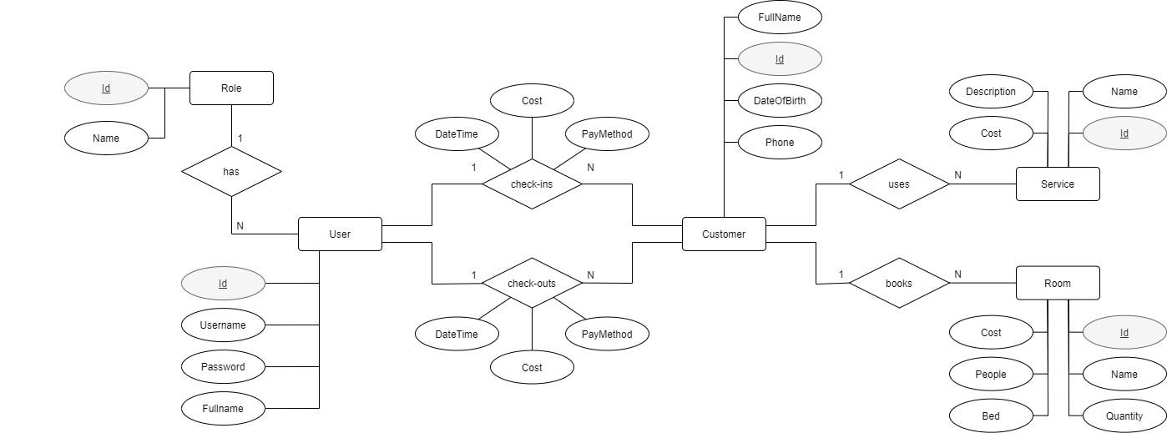

**Figure . Partial data model for release 1.0 of the Hotel Management System.**

## Data Dictionary

|  |  |  |  |  |
| --- | --- | --- | --- | --- |
| **Data Element** | **Description** | **Composition or Data Type** | **Length** | **Values** |
| UserID | User ID number of the hotel  staff | integer | 8 |  |
| username | Username to identify a login user of hotel system | alphanumeric | 8 - 16 | special characters are not allowed |
| password | Secret to identify a username login to hotel system | alphanumeric | 10 - 20 | special characters are allowed |
| User fullname | A user full name | alphanumeric | 50 | special characters are not allowed |
| Role ID | Role ID number of the hotel  staff to identify what kind of user | integer | 6 |  |
| Role Name | Name of a role | alphanumeric | 30 | special characters are not allowed |
| Service ID | Service ID number that available in hotel | integer | 6 |  |
| Service Cost | Price for a Service in hotel | numeric, Viet Nam Dong |  |  |
| Service Name | Name of a Service in hotel | alphanumeric | 50 | special characters are not allowed |
| Service Description | Description of a Service to know what service about | alphanumeric | 70 | special characters are not allowed |
| Room ID | Room ID number that available in hotel | integer | 6 |  |
| Room Cost | Price for a Room in hotel | numeric, Viet Nam Dong |  |  |
| Room People | Number of people can be assign in one room | integer | 1- 6 |  |
| Room Bed | What kind of bed does this room have | alphanumeric | 50 | special characters are not allowed |
| Room Name | Name of a Roomin hotel | alphanumeric | 30 | special characters are not allowed |
| Room Quantity | Number of one type of room in the hotel | integer | 8 - 12 |  |
| Customer ID | CustomerID number that registration to the hotel | integer | 6 |  |
| Customer Fullname | Full name of a customer | alphanumeric | 50 | special characters are not allowed |
| Customer Date of Birth | Date of birth of a customer | date, MM/DD/YYYY | 10 |  |
| Customer Phone Number | Phone number of a customer to contact | numeric | 11 |  |
| Check-ins date time | Date and time when a customer check in to the hotel | datetime, MM/DD/YYYY : HH:MM | 18 |  |
| Check-ins cost | The cost customer have to prepay to check in to the hotel | numeric, Viet Nam Dong |  |  |
| Check-ins payment method | The method customer use to prepay for check in hotel | MoMo/Internet Banking/Hand Cash | 20 |  |
| Check-out date time | Date and time when a customer check out of the hotel | datetime, MM/DD/YYYY : HH:MM | 18 |  |
| Check-out cost | The rest money customer have to pay to check out to the hotel | numeric, Viet Nam Dong |  |  |
| Check-out payment method | The method customer use to prepay for check out of the hotel | MoMo/Internet Banking/Hand Cash | 20 |  |

## Reports

### Check-in history Report

|  |  |
| --- | --- |
| Report ID: | HMS-RPT-1 |
| Report Title: | Check-in history |
| Report Purpose: | Receptionist wants to see a list of check-in information that he/she had previously saved to the HMS over a specified time period up to three months prior to the current date, so he/she can make a statistics about it |
| Priority: | High |
| Report Users: | Receptionist |
| Data Sources: | Database of previously Check in |
| Frequency and Disposition; | Report is generated on demand by Hotel Staff. Data in the report is static. Report is displayed on the user's application screen on a computer. It can be printed if the display device permits printing. |
| Latency: | Complete report must be displayed to receptionist within 1 seconds after it is requested. |
| Visual Layout: | Landscape mode |
| Header and Footer: | Report header shall contain the report title, Check-in id, check-in customer name, room arranged, service used and check-in date with date range specified by Receptionist. If printed, report footer shall show the page number. |
| Report Body: | Fields shown and column headings:   * Check-in ID number * Customer Name * Customer ID * Customer Phone * Room Arranged ID and Name * Service Arranged ID and Name * Check-in Date * Payment * Prepay Price (sum room and services cost)   Selection Criteria: date range specified by receptionist, inclusive of end points  Sort Criteria: reverse chronological order |
| End-of-Report Indicator: | None |
| Interactivity: | Receptionist can drill down to see the entire list |
| Security Access Restrictions: | Receptionist may only his own meal order history |

### Check-out history Report

|  |  |
| --- | --- |
| Report ID: | HMS-RPT-1 |
| Report Title: | Check-out history |
| Report Purpose: | Receptionist wants to see a list of check-out information that he/she had previously saved to the HMS over a specified time period up to three months prior to the current date, so he/she can make a statistics about it |
| Priority: | High |
| Report Users: | Receptionist |
| Data Sources: | Database of previously Check out |
| Frequency and Disposition; | Report is generated on demand by Hotel Staff. Data in the report is static. Report is displayed on the user's application screen on a computer. It can be printed if the display device permits printing. |
| Latency: | Complete report must be displayed to receptionist within 1 seconds after it is requested. |
| Visual Layout: | Landscape mode |
| Header and Footer: | Report header shall contain the report title, Check-out id, check-out customer name, room arranged, service used, description and check-out date with date range specified by Receptionist. If printed, report footer shall show the page number. |
| Report Body: | Fields shown and column headings:   * Check-out ID number * Customer Name * Customer ID * Customer Phone * Room Arranged ID and Name * Service Arranged ID and Name * Description * Check-out Date * Payment * Prepay Price (sum room and services cost)   Selection Criteria: date range specified by Receptionist, inclusive of end points  Sort Criteria: reverse chronological order |
| End-of-Report Indicator: | None |
| Interactivity: | Receptionist can drill down to see the entire list |
| Security Access Restrictions: | Receptionist may only his own meal order history |

## Data Integrity, Retention, and Disposal

# External Interface Requirements

## User Interfaces

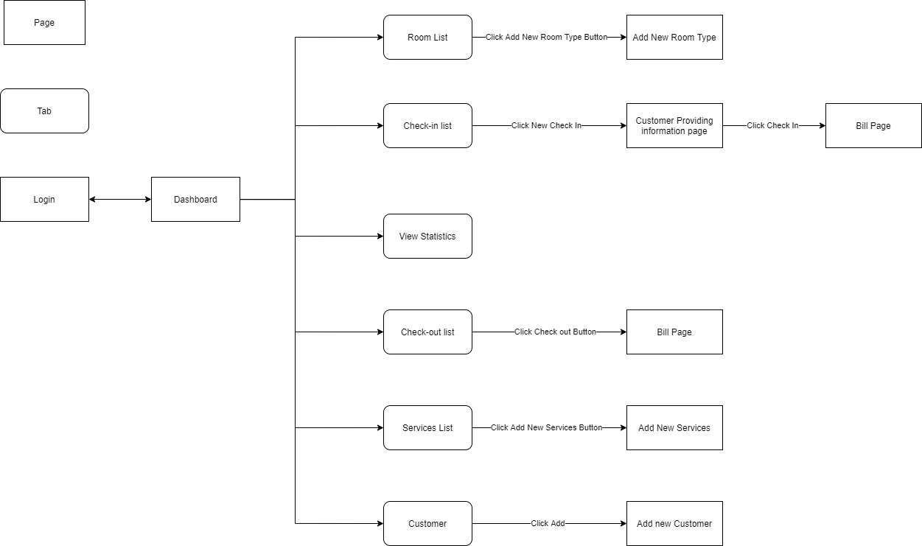

## Software Interfaces

SI-1: Hotel Inventory System

SI-1.1: The HMS shall transmit the number of people and the number of check-in to the Hotel Inventory System through a programmatic interface.

SI-1.2: The HMS shall poll the Hotel Inventory System to determine whether a requested hotel room is available.

SI-1.3: When the Hotel Inventory System notifies the HMS that a particular room is no longer available.

SI-1.4: The HMS will poll the Hotel Inventory System to determine if the requested hotel menu is available.

SI-1.5: When the hotel Inventory System notifies HMS will remove that item from the menu of the current day.

SI-2: Payroll System

The HMS shall communicate with the Payroll System through a programmatic interface for the following operations:

SI-2.1: To allow Customers to register and unregister from payroll deduction.

SI-2.2: To inquire whether Customers are registered for payroll deduction.

SI-2.3: To inquire whether Customers are eligible to register for payroll deduction.

SI-2.4: To submit a payment request for a booking invoice.

SI-2.5: To reverse all or part of a previous charge because Customers rejected Booking or weren't satisfied with the hotel’s service.

## Hardware Interfaces

No hardware interfaces have been identified.

## Communications Interfaces

CI-1: The HMS shall send an email or text message (based on user account settings) to the Customer to confirm Booking acceptance, price, and check-in time.

CI-2: The HMS shall send an email or text message (based on user account settings) to the Customer to report any problems with order room or food order.

# Quality Attributes

## Usability Requirements

USE-1: The HMS shall allow customers to retrieve their previous reservation and food order in just 45 seconds. After 45 seconds, the hotel staff has confirmed that if you want to cancel the reservation, you must contact the hotel staff.

USE-2: 95% of new users shall be able to successfully check in and check out without errors on their first try.

## Performance Requirements

PER-1: The system shall accommodate a total of 1 user and a maximum of 10 concurrent users during working-time.

PER-2: 100% data will be saved safely.

PER-3: The system shall display confirmation messages to users within an average of 1 seconds and a maximum of 2 seconds after the user submits information to the system.

PER-4: The system shall display data to users within an average of 1 seconds and a maximum of 3 seconds after the user requests to see information to the system.

## Security Requirements

SEC-1: All network transactions that involve financial information or personally identifiable information shall be encrypted

SEC-2: Users must log in to the HMS for all operations.

SEC-3: Only hotel employees are authorized to manipulate, edit and manage all customer information, and manipulate food and menu orders

SEC-4: The system will allow users to review past and current booking information.

## Safety Requirements

SAF-1: The user will be able to see a list of all hotel rooms and hotel menu. Regarding hotel rooms, customers can see reviews of quality, room rates and promotions that customers receive when booking by type. On the hotel menu, customers can see the price of the dish, the ingredients of the dish.

## Availability Requirements

AVL-1: Data update time before working time 8:00 am and after 8:00 pm

## Robustness Requirements

ROB-1: If the payment process fails, allow the system to reuse the saved information to issue a new receipt.